Be Respectful!
Group 4
♥ how to be respectful ♥
- Be kind to others.
- Don’t run in the halls Be safe.
- Be engaged.
- Be respectful.
- Keep your personal space.
- Don’t be rude to teachers or other students.
- don’t hurt others.
- don’t color on equitment.
- don’t rip teachers things.
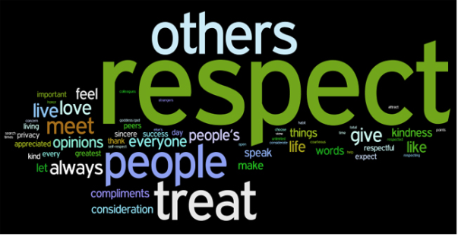
- throw away your trash.

